**Experiment No. 09**

**Object:** Inter VLAN Routing

**Date:** March 31, 2018

# Configuration Figure:

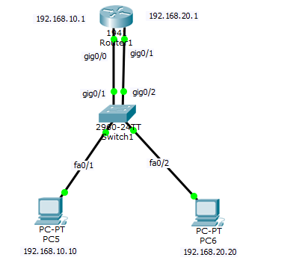

# Coding: *On Router*

Press RETURN to get started!

Router>en

Router#conf t

Enter configuration commands, one per line. End with CNTL/Z.

Router(config)#in

Router(config)#interface g

Router(config)#interface gigabitEthernet 0/0

Router(config-if)#ip a

Router(config-if)#ip ad

Router(config-if)#ip address 192.168.10.1 255.255.255.0

Router(config-if)#no sh

Router(config-if)#no shutdown

Router(config-if)#

%LINK-5-CHANGED: Interface GigabitEthernet0/0, changed state to up

%LINEPROTO-5-UPDOWN: Line protocol on Interface GigabitEthernet0/0, changed state to up

Router(config-if)#ex

Router(config)#

Router(config)#interface gigabitEthernet 0/1

Router(config-if)#ip address 192.168.20.1 255.255.255.0

Router(config-if)#no shutdown

Router(config-if)#

%LINK-5-CHANGED: Interface GigabitEthernet0/1, changed state to up

%LINEPROTO-5-UPDOWN: Line protocol on Interface GigabitEthernet0/1, changed state to up

ex

Router(config)#

Router(config)#ex

Router#

%SYS-5-CONFIG_I: Configured from console by console

Router#

# Coding: *On Switch*

Switch>

Switch>en

Switch#conf t

Enter configuration commands, one per line. End with CNTL/Z.

Switch(config)#

Switch(config)#vlan 10

Switch(config-vlan)#ex

Switch(config)#vlan 20

Switch(config-vlan)#ex

Switch(config)#

Switch(config)#interface gigabitEthernet 0/1

Switch(config-if)#switchport access vlan 10

Switch(config-if)#no shutdown

Switch(config-if)#ex

Switch(config)#

Switch(config)#interface gigabitEthernet 0/2

Switch(config-if)#switchport access vlan 20

Switch(config-if)#no shutdown

Switch(config-if)#ex

Switch(config)#

Switch(config)#

Switch(config)#in

Switch(config)#interface fa0/1

Switch(config-if)#switchport access vlan 10

Switch(config-if)#ex

Switch(config)#

Switch(config)#interface fa0/2

Switch(config-if)#switchport access vlan 20

Switch(config-if)#ex

Switch(config)#

Switch(config)#

%LINK-5-CHANGED: Interface FastEthernet0/10, changed state to down

%LINEPROTO-5-UPDOWN: Line protocol on Interface FastEthernet0/10, changed state to down

# Ping Test:

